November 24, 2014

Andy Thind,
Sukhmander Gill
9401 LBJ Freeway, Suite #305
Dallas, TX 75243

Re: Westridge Park Addition, Section 24 Lots, 6A and 6B

Dear Mr. Thind:

On behalf of the owner of Westridge Park Addition, Section 24 Lots 6B & 6C the information provided by Mozharul Islam, of CUA/Civil Urban Associates, Inc, has been received and coordinated between the two projects. It has been agreed upon that construction will be coordinated between the two parties. Red Oak is willing to take on a little more drainage from the Wingate site while the Wingate site is willing to work with Red Oak on construction coordination and timing of the installation of the main sewer line for the Red Oak Retail project that is routed within the C.O.M. Access and Utility easement per Westridge Park Addition, Sec 24 Plat.

Please do not hesitate to contact me at 432-262-0999 or amellen@maverick-eng.com should you have questions.

Sincerely,

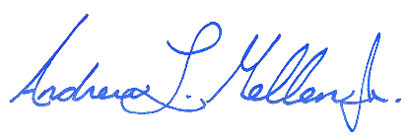
Maverick Engineering

Andrew L. Mellen, P.E.
Managing Partner

ALM/GR

